**Question 1:**

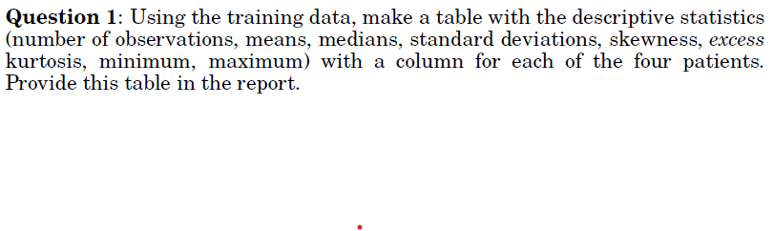

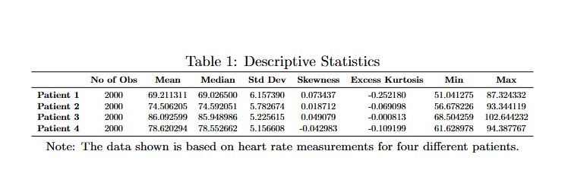Answer:

**Question 2:**

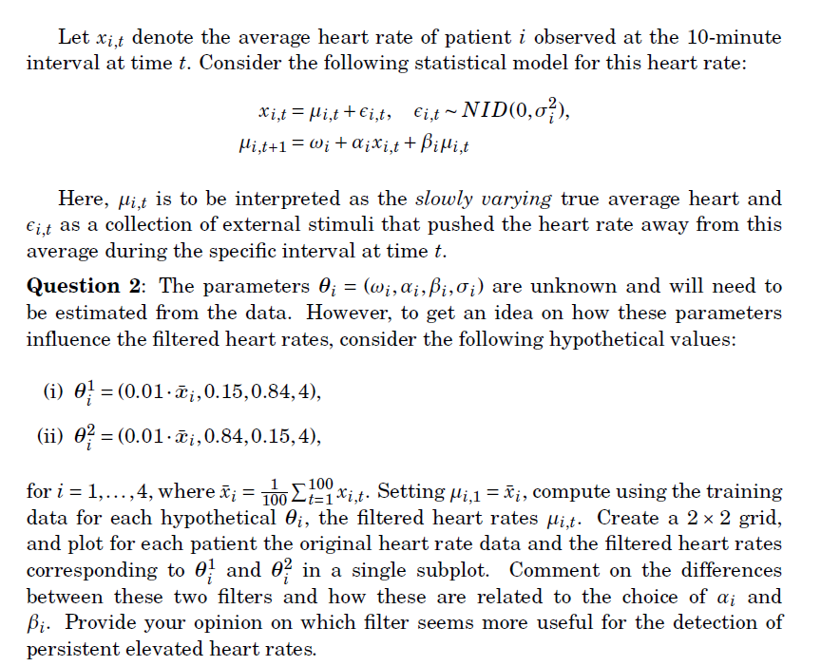

Answer:

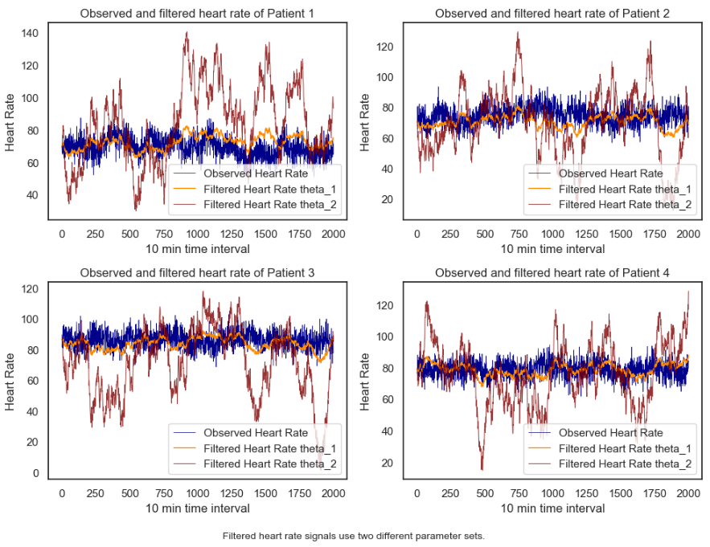

Comments & Opinion:

From the four plots above, it is evident that the second parameter set (with higher alpha than beta) is highly sensitive to changes in the heart rates of the patients, responding quickly to even minor fluctuations. This results in the filter closely following the observed heart rate. In contrast, the first parameter set (with higher beta than alpha) shows a smoother response, with less sensitivity to rapid changes, as it retains previous heart rate values more strongly, leading to a more gradual and stable filtering effect.

For the detection of persistent elevated heart rates, the first parameter set is preferable. Its higher beta value ensures that the filter smooths out short-term fluctuations and places more emphasis on the long-term trend, making it less reactive to temporary spikes. The lower alpha value further contributes to the filter’s stability, helping to avoid false positives due to transient changes. This combination makes the first parameter set more reliable for detecting sustained increases in heart rate, which is crucial for identifying potential health concerns.

**Question 3:**

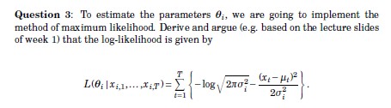

Answer:



**Question 4:**



Answer:

The log-likelihood value for patient 1 using the given parameter set (0.7, 0.15, 0.84, 4) is **-6173.7754**

**Question 5:**

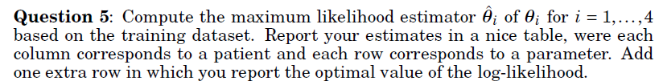

Answer:

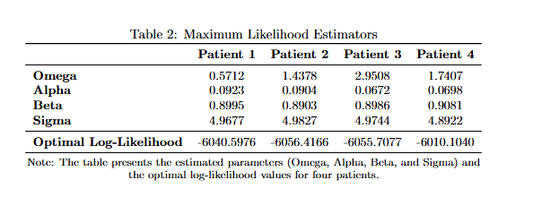

**Question 6:**

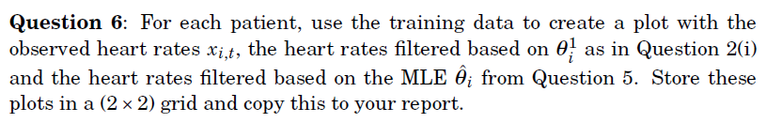

Answer:

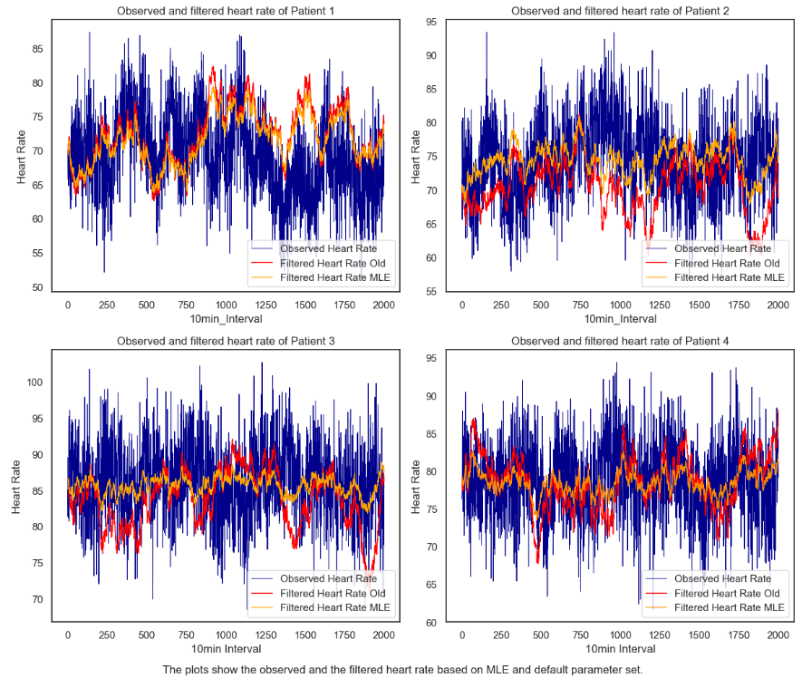

**Question 7:**

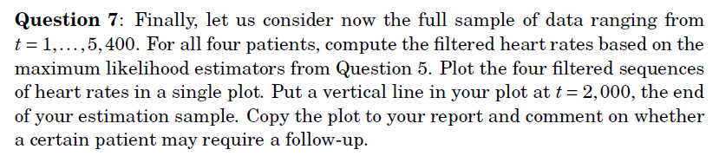

Answer:

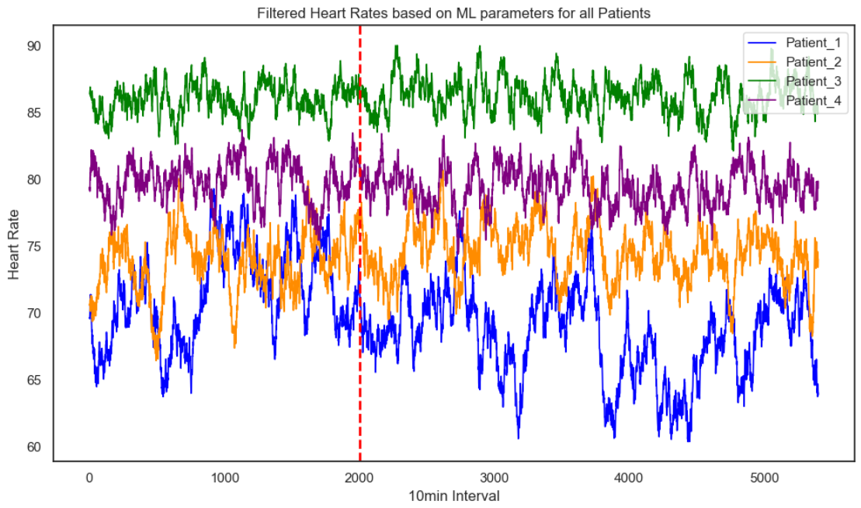

Observation:

From the above plot, Patients 1 and 2 show noticeable fluctuations in their heart rates over time, with significant dips and spikes, particularly after t = 2000. These variations suggest some instability in their heart rates, which could raise concerns for cardiovascular health. As a result, these two patients should be given priority for follow-up to ensure that no serious health issues are developing.

On the other hand, Patients 3 and 4 have consistently elevated heart rates, but they remain stable without major fluctuations. While their heart rates are higher, the steady pattern makes them less of an immediate concern compared to Patients 1 and 2. Therefore, follow-up should primarily focus on Patients 1 and 2 to check for any potential health risks.